Question 1 :- Create Database.
Answer 1 :-
create database customers_product;

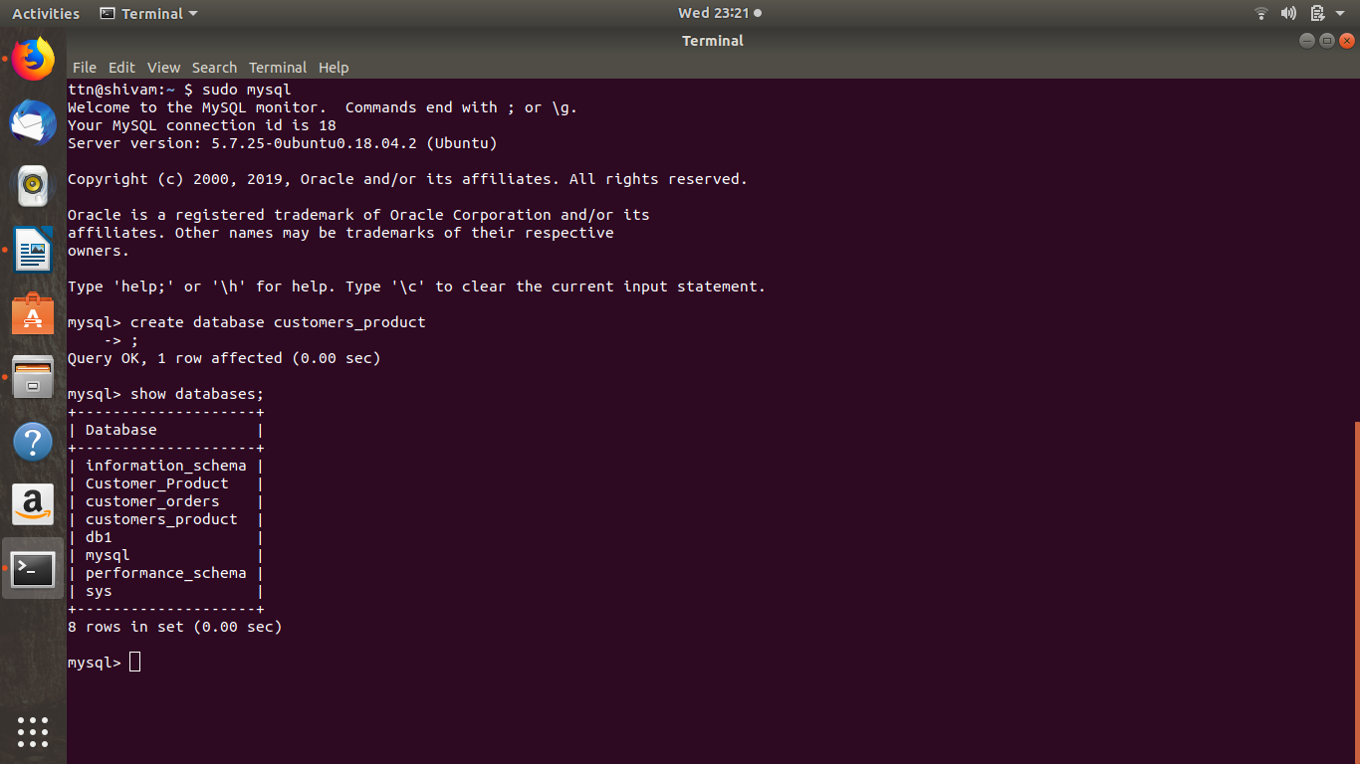

Question 2 :- Design Schema
Answer 2 :- desc customer; desc order1; desc salesperson;

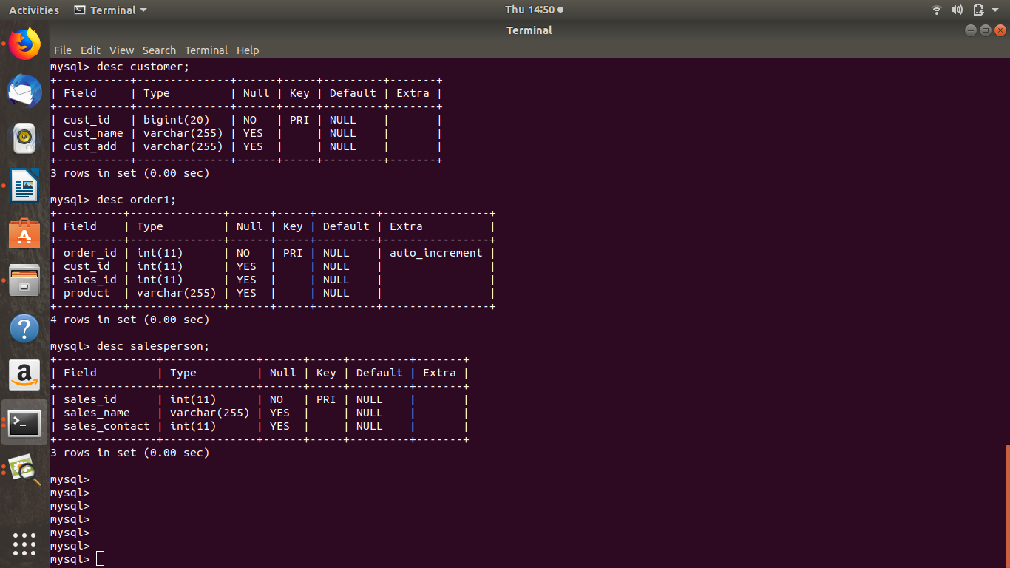
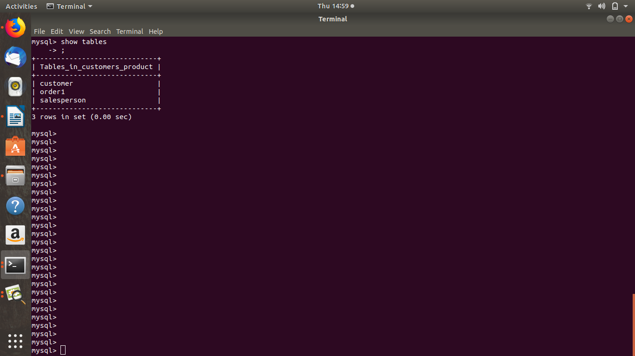

Question 3 : Create tables
Answer 3 : create table customer (
cust_id bigint(20),
cust_name VARCHAR(255),
cust_add VARCHAR(255),
PRIMARY KEY(cust_id)
);

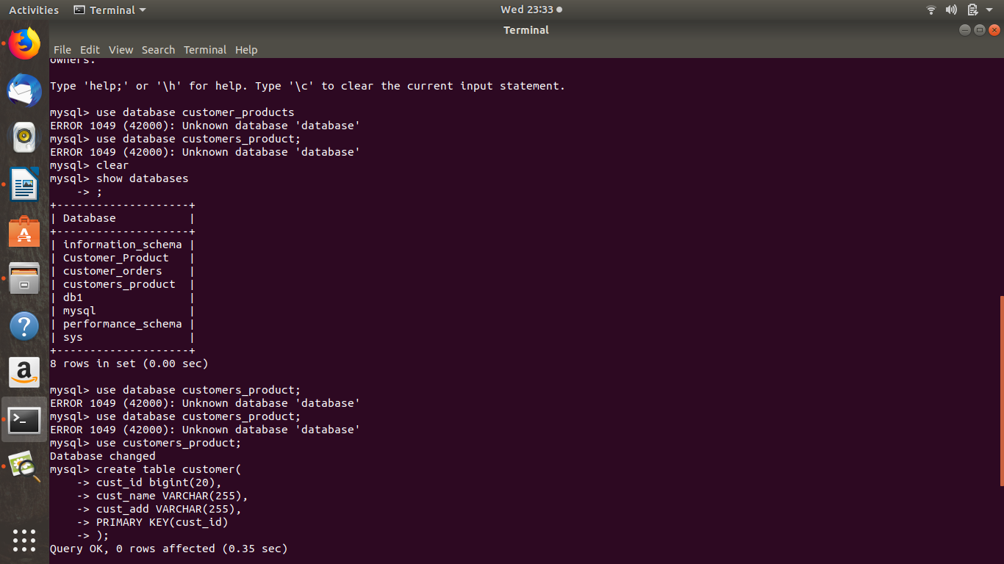
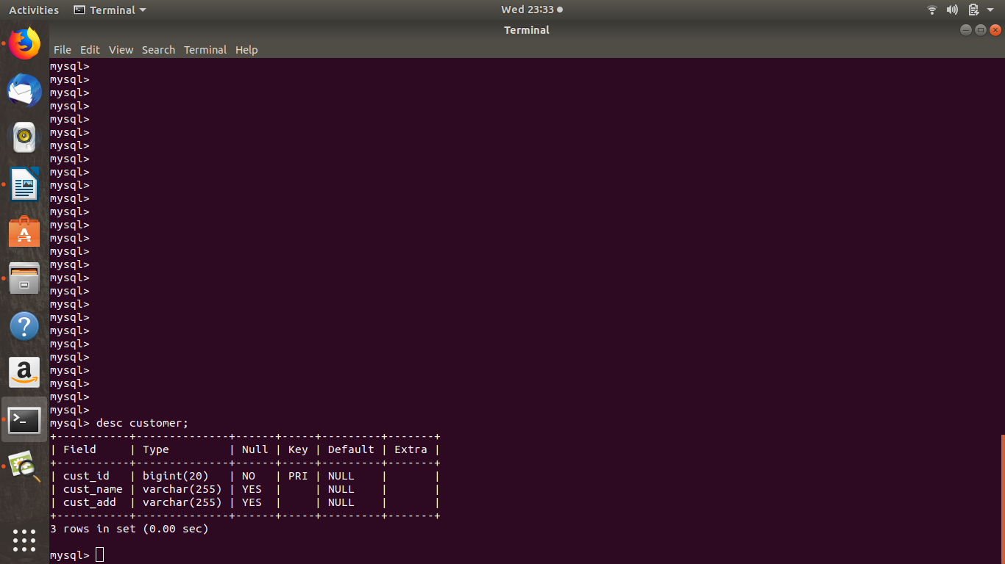

create table order1 (
order_id int NOT NULL AUTO_INCREMENT,
cust_id int,
sales_id int,
product VARCHAR(255),
PRIMARY KEY(order_id)
);

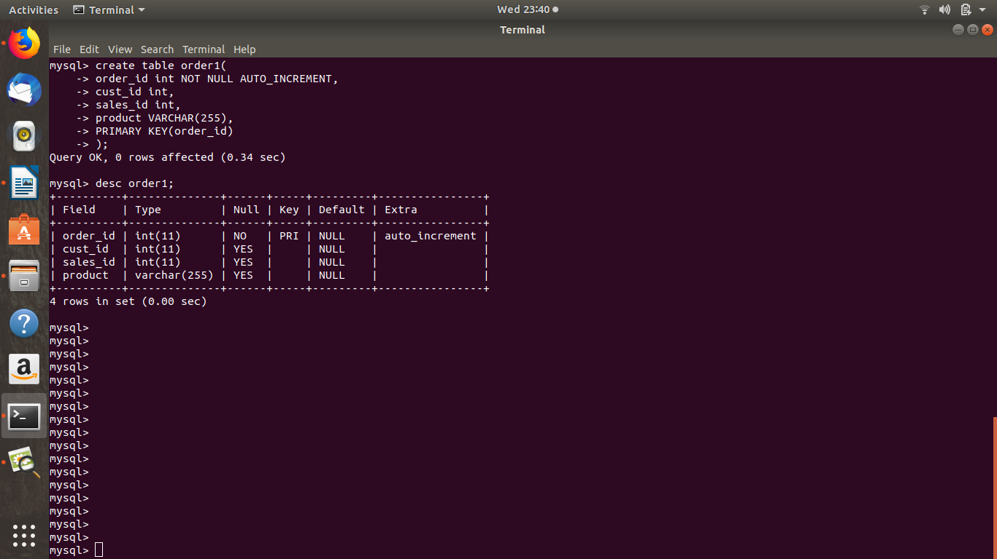

create table salesperson(
sales_id int( NOT NULL,
sales_name VARCHAR(255),
sales_contact int,
PRIMARY KEY(sales_id)
);
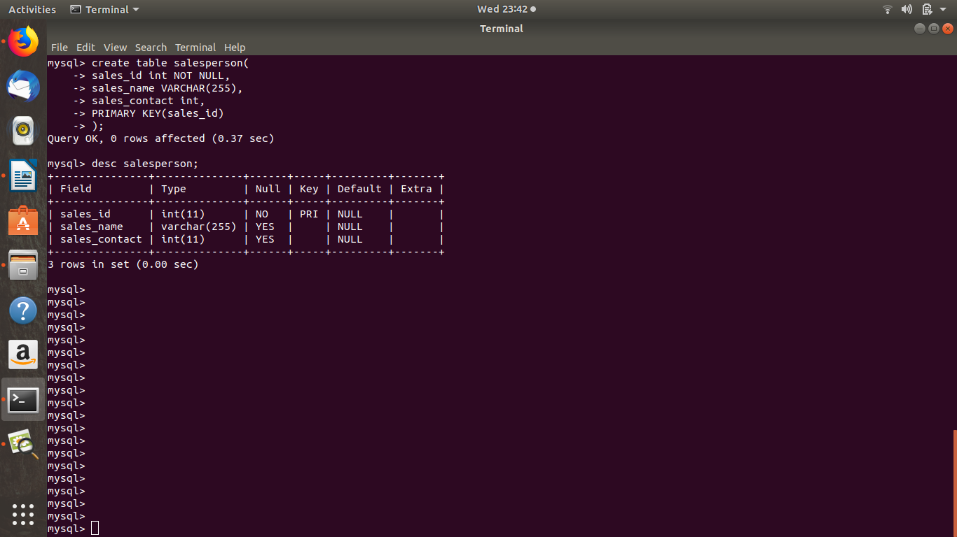

Question 4 :- Insert sample data
Answer 4 :- insert into customer(cust_id,cust_name,cust_add) values (1,”shivam”,”hill station”),(2,”mansu”,”station”),(3,”mansul”,”multi station”),(4,”meena”,”newyork”),(5,”vishal”,”swedan”);

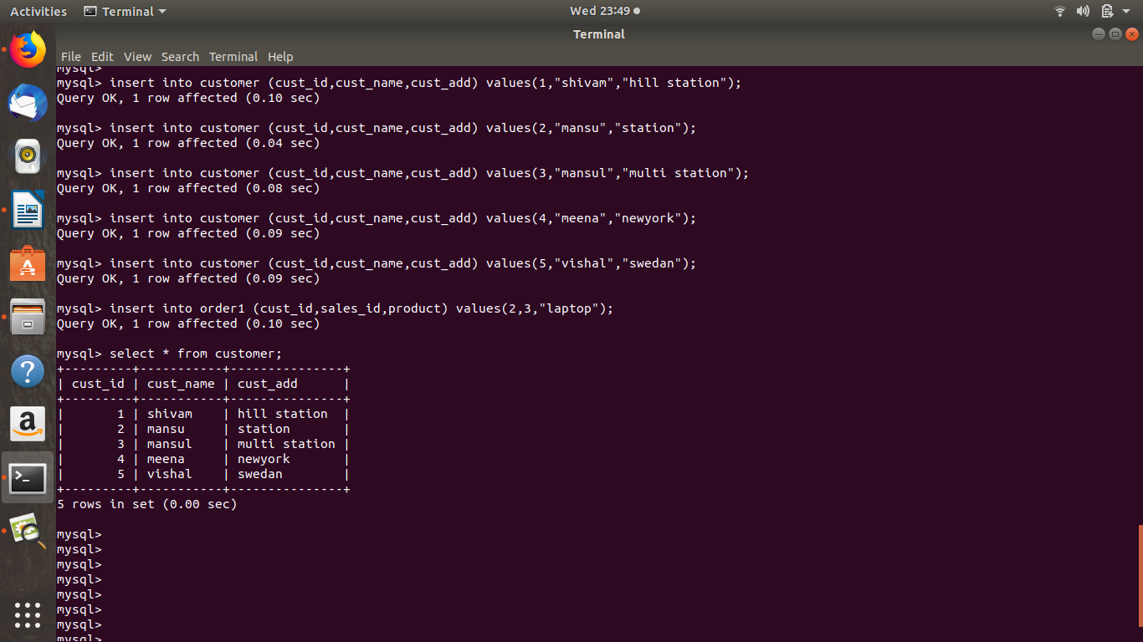

insert into order1(cust_id,sales_id,product) values (2,3,”laptop”),(1,1,”dryer”),(4,3,”shoes”),(3,2,”mobile”),(1,2,”shampoo”),(3,3,”bottle”);
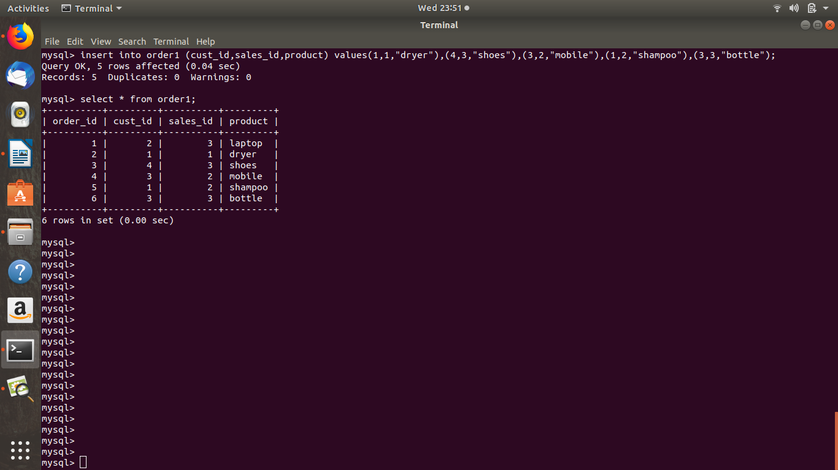

insert into salesperson(sales_id,sales_name,sales_contact) values (1,”ram”,9898989),(2,”shyam”,8989898),(3,”ramish”,78787878);

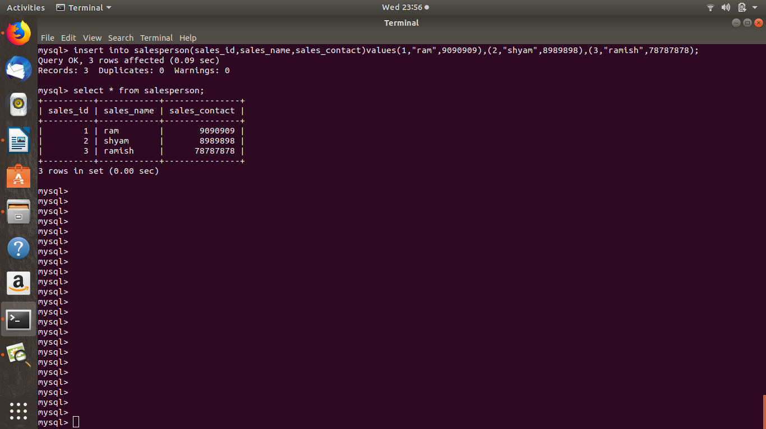

Question 5 : Find the sales person have multiple orders.
Answer 5 : select sales_id,COUNT(*)from order1 GROUP BY sales_id HAVING COUNT(*)>1;

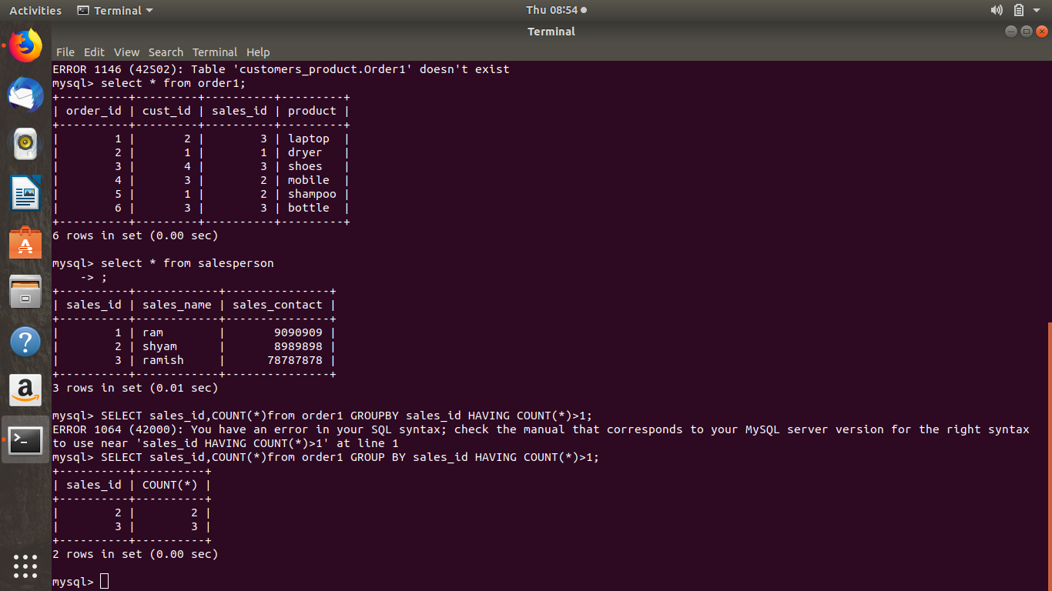

Question 6 :- Find the all sales person details along with order details.
Answer 6 :- select order1.order_id, order1.cust_id, order1.sales_id, order1.product, salesperson.sales_id, salesperson.sales_name, salesperson.sales_contact from salesperson INNER JOIN order1 ON salesperson.sales_id = order1.order_id;

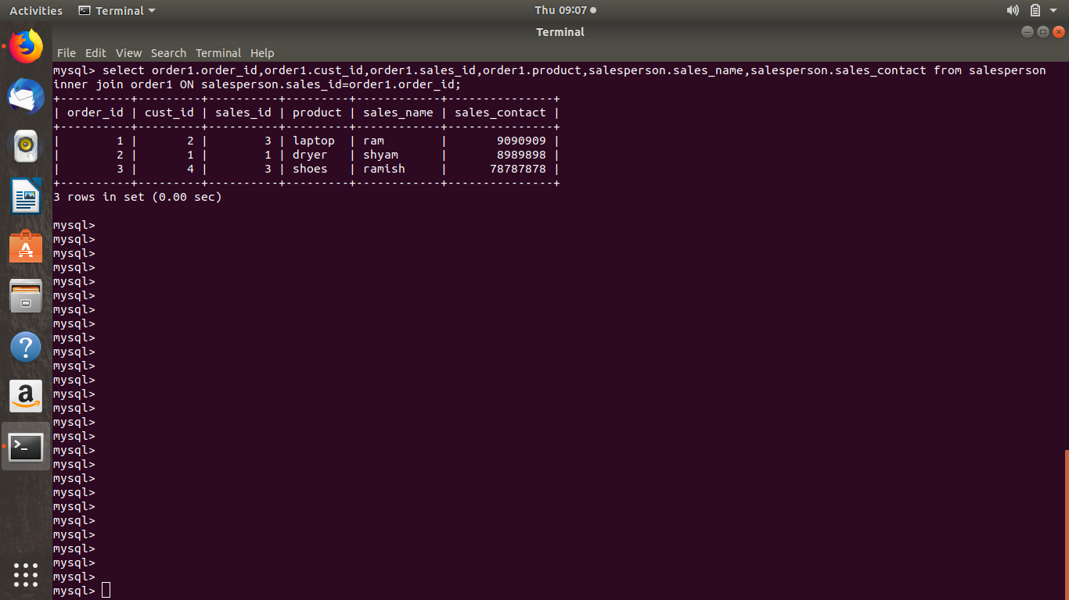

Question 7 : Create index
Answer 7: create INDEX order1_index ON order1(order_id);

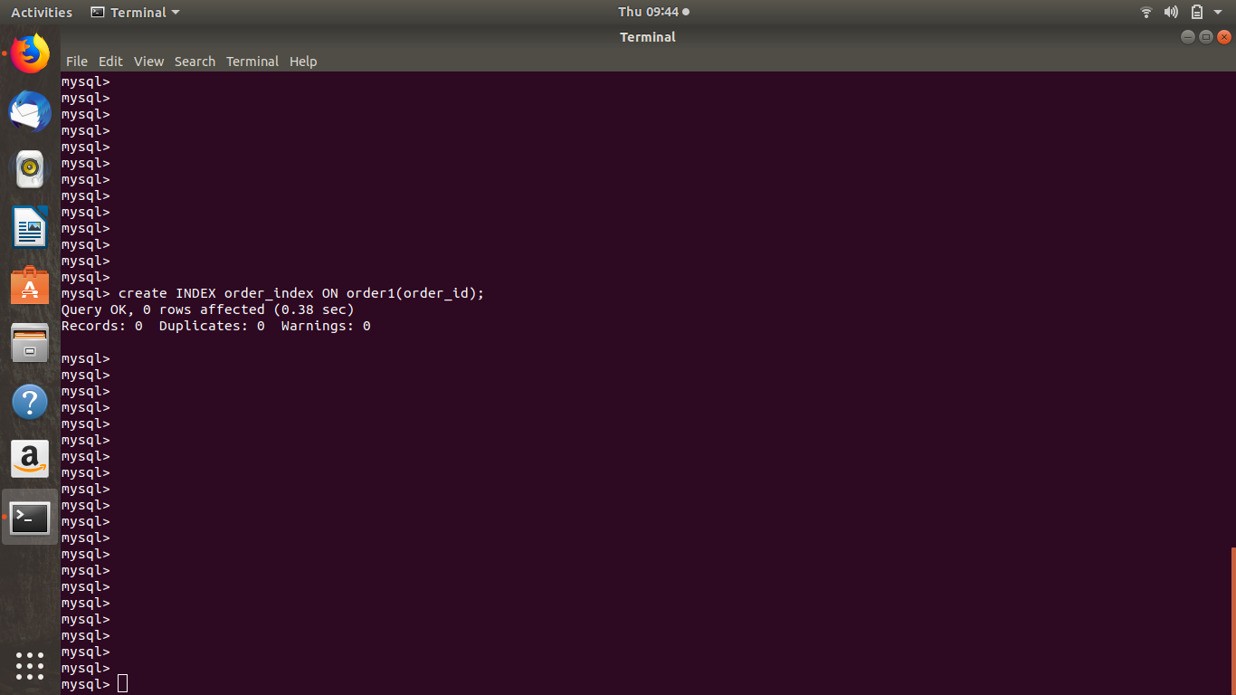

Question 8 : How to show index on a table
Answer 8 : show INDEX from order1;

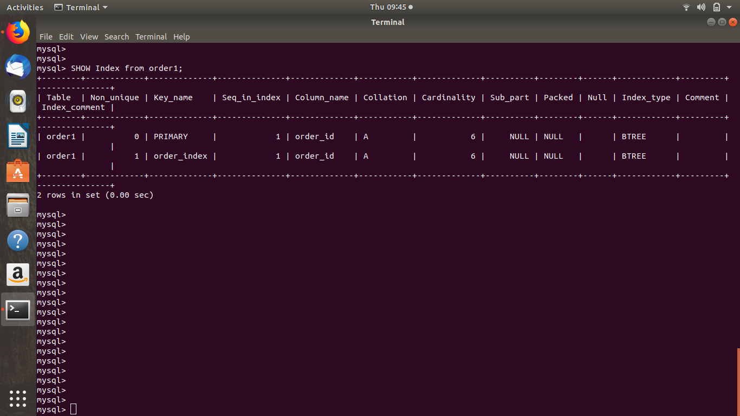

Question 9 :- Find the order number, sale person name, along with the customer to whom that order belongs to
Answer 9 :- select customer.cust_name, order1.order_id, salesperson.sales_name FROM(order1 INNER JOIN salesperson ON salesperson.sales_id=order1.sales_id) INNER JOIN customer ON customer.cust_id=order1.cust_id);

